**DATABASE (STORED PROCEDURE)**

**201133216 정유석**

**INSERT :**

* **Database**

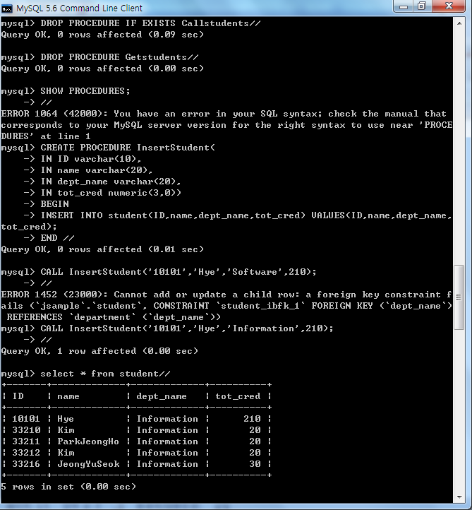

* **JDBC**

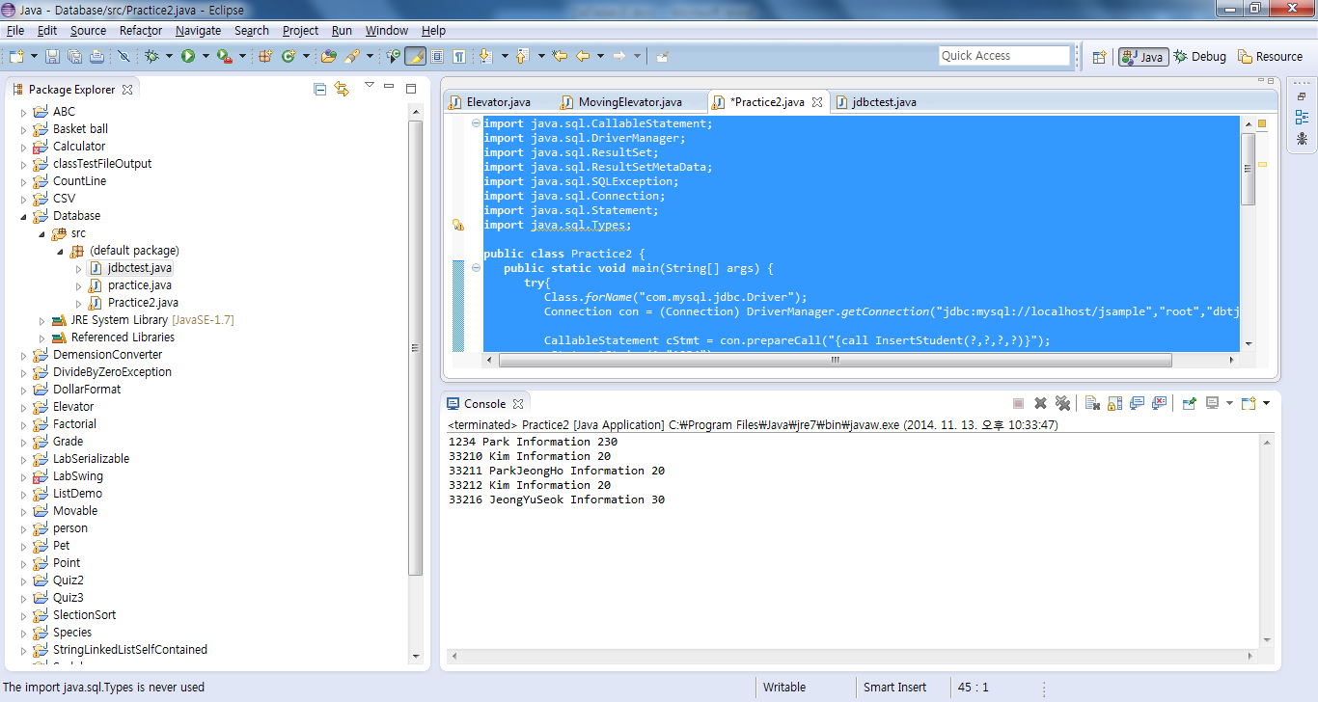

**import** java.sql.CallableStatement;

**import** java.sql.DriverManager;

**import** java.sql.ResultSet;

**import** java.sql.ResultSetMetaData;

**import** java.sql.SQLException;

**import** java.sql.Connection;

**import** java.sql.Statement;

**import** java.sql.Types;

**public** **class** Practice2 {

**public** **static** **void** main(String[] args) {

**try**{

Class.*forName*("com.mysql.jdbc.Driver");

Connection con = (Connection) DriverManager.*getConnection*("jdbc:mysql://localhost/jsample","root","dbtjr7864");

CallableStatement cStmt = con.prepareCall("{call InsertStudent(?,?,?,?)}");

cStmt.setString(1,"1234");

cStmt.setString(2,"Park");

cStmt.setString(3,"Information");

cStmt.setInt(4,230);

cStmt.executeUpdate();

cStmt.close();

Statement stmt2 = con.createStatement();

ResultSet rs = stmt2.executeQuery("Select * from student");

ResultSetMetaData rsmd = rs.getMetaData();

**int** colnum = rsmd.getColumnCount();

**while**(rs.next()){

**for**(**int** i =1; i<=colnum; i++){

System.*out*.print(rs.getString(i)+" ");

}

System.*out*.println();

}

rs.close();

cStmt.close();

con.close();

}

**catch**(SQLException e){

e.printStackTrace();

}

**catch**(ClassNotFoundException e){

e.printStackTrace();

}

}

}

**SELECT :**

* **DATABASE**

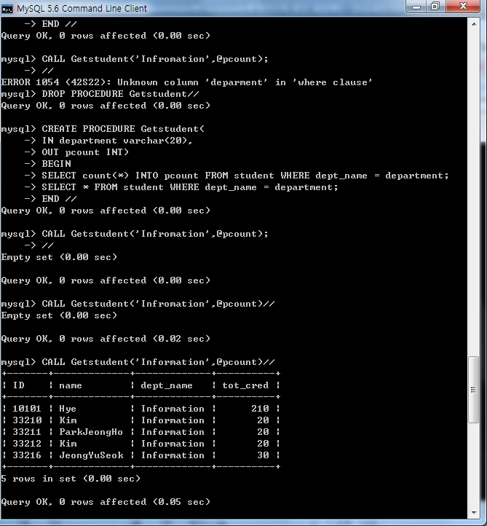

* **JDBC**

import java.sql.CallableStatement;

import java.sql.DriverManager;

import java.sql.ResultSet;

import java.sql.ResultSetMetaData;

import java.sql.SQLException;

import java.sql.Connection;

import java.sql.Types;

public class Practice2 {

public static void main(String[] args) {

try{

Class.forName("com.mysql.jdbc.Driver");

Connection con = (Connection) DriverManager.getConnection("jdbc:mysql://localhost/jsample","root","dbtjr7864");

CallableStatement cStmt = con.prepareCall("{call getstudents1(?, ?)}");

cStmt.setString(1,"Information");

cStmt.registerOutParameter(2,Types.INTEGER);

ResultSet rs = cStmt.executeQuery();

ResultSetMetaData rsmd = rs.getMetaData();

int colnum = rsmd.getColumnCount();

while(rs.next()){

for(int i =1; i<=colnum; i++){

System.out.print(rs.getString(i)+" ");

}

System.out.println();

}

System.out.println(cStmt.getInt(2));

rs.close();

cStmt.close();

con.close();

}

catch(SQLException e){

e.printStackTrace();

}

catch(ClassNotFoundException e){

e.printStackTrace();

}

}

}

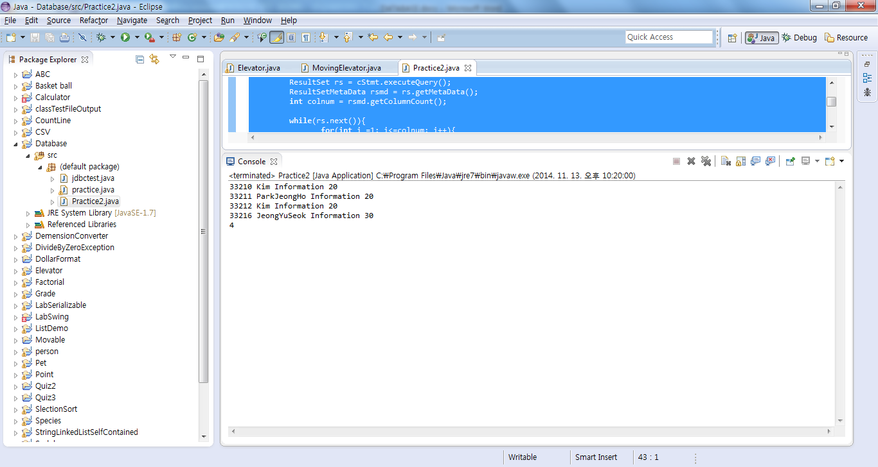

**DELETE:**

* **database**

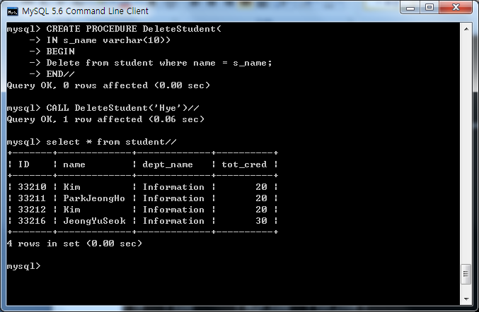

* **JDBC**

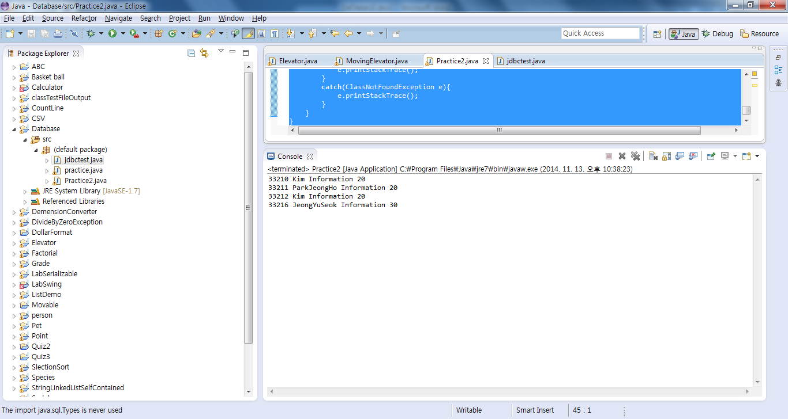

**import** java.sql.CallableStatement;

**import** java.sql.DriverManager;

**import** java.sql.ResultSet;

**import** java.sql.ResultSetMetaData;

**import** java.sql.SQLException;

**import** java.sql.Connection;

**import** java.sql.Statement;

**import** java.sql.Types;

**public** **class** Practice2 {

**public** **static** **void** main(String[] args) {

**try**{

Class.*forName*("com.mysql.jdbc.Driver");

Connection con = (Connection) DriverManager.*getConnection*("jdbc:mysql://localhost/jsample","root","dbtjr7864");

CallableStatement cStmt = con.prepareCall("{call DeleteStudent(?)}");

cStmt.setString(1,"Park");

cStmt.executeUpdate();

cStmt.close();

Statement stmt2 = con.createStatement();

ResultSet rs = stmt2.executeQuery("Select * from student");

ResultSetMetaData rsmd = rs.getMetaData();

**int** colnum = rsmd.getColumnCount();

**while**(rs.next()){

**for**(**int** i =1; i<=colnum; i++){

System.*out*.print(rs.getString(i)+" ");

}

System.*out*.println();

}

rs.close();

cStmt.close();

con.close();

}

**catch**(SQLException e){

e.printStackTrace();

}

**catch**(ClassNotFoundException e){

e.printStackTrace();

}

}

}